BCT 2313 MAKEUP SCT212-0475/2017 YVONNE KIMANI

PRODUCT ORDERING AND DELIVERY SYSTEM.

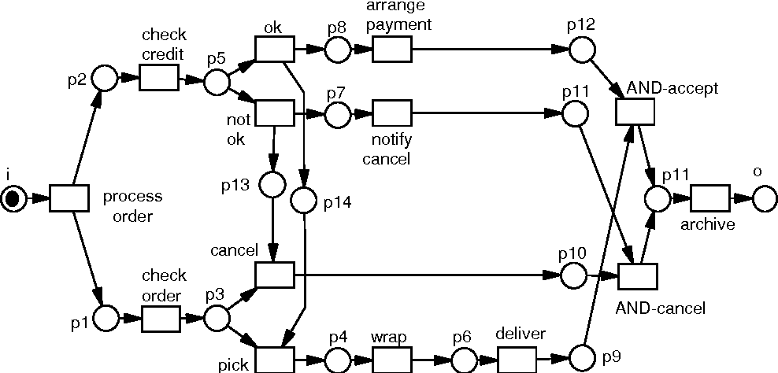

When a customer makes an order, the order is processed. His or her credit is checked. If the credit is good, payment arrangements are made. If it is bad, the order is cancelled and a cancelling notification is made. Once the payment arrangement is accepted, it is archived.

The order has to be checked for the process to continue. Otherwise, the order will be cancelled.

After checking, item ordered is picked up from the warehouse, wrapped and shipped. This also goes for situation in which customer credit is good.

Successful orders and delivers are archived. The same goes for any order cancellations. This helps remove them from the default order history view.